**Analysis:**

The Bureau of Labor Statistics provided us with a data set that gave insight into the growth of for Data Scientists and Mathematical Science roles throughout a 2-year period. There was an almost 4x increase in roles related to these positions. The drastic increase in Data Science and Mathematical Science roles involved with Data Analysis shows a large need for specialists within this field. Further indicating to the market, the potential growth in the coming years.

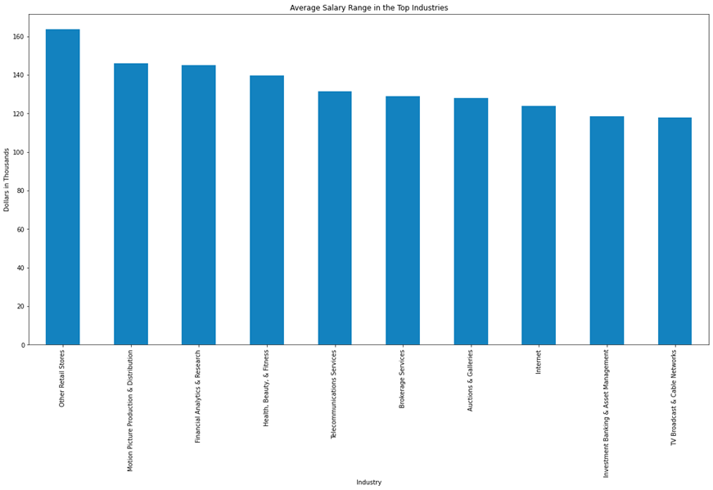

**Analysis:**

The bar graph displays the average salary range for the top 10 Data Analytics Industries in the United States. The method to make the bar chart was by implementing a groupby of the data set, which included ‘Industry’ and ‘Avg Salary,’ and then getting the average of the resulting data. It was interesting to find that the highest average salary appeared in the retail industry. However, I would like to add that one of the many limitations to the data set is that GlassDoor gathers data from ratings/responses from employees. Hence, the data pull is not as significant compared to a dataset from the bureau of labor of statistics.

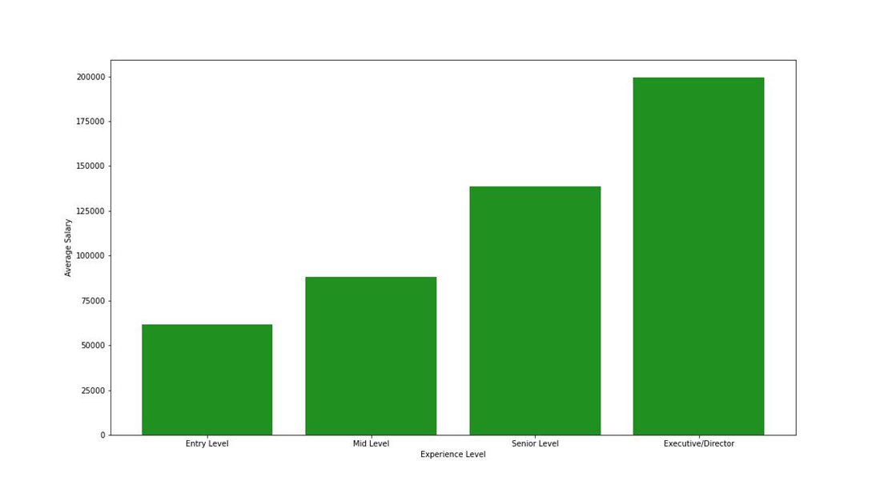

**Analysis:**

This data gives insight into the average salary based on experience level. We used matplot to create the ascending average income from entry level to executive director positions. A great representation of how one’s income has great potential to increase as you traverse through entry level roles up to senior and executive roles within the industry. At mid-level you are just shy of 100k, and a senior level role can average well above 125k a year salary. If this isn’t a great indicator to the benefits of the industry, I'm not sure what is.

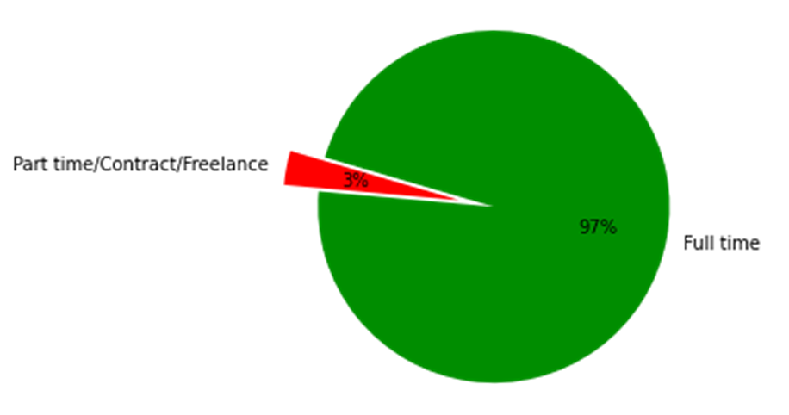

**Analysis:**

**This** pie chart created with matplotlib demonstrates a huge disparity between part time and full-time workers within this industry. It paints a strong indicator that most workers who work in the data field are part time workers. Only 3% of workers are part time, contract, or freelance, and a whopping 97% of workers have a full-time role. A great indication that if you are looking to work within the data field you won’t be hurting for hours. No need to split your time between two part time jobs.



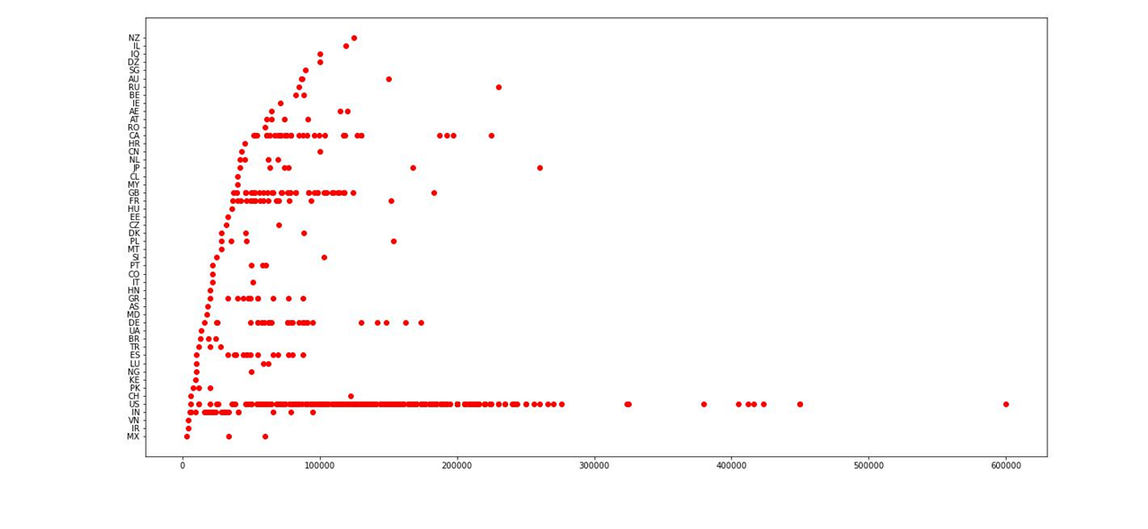

**Analysis:**

This scatterplot depicts a sorted data set of salaries between several countries worldwide. The scatterplot describes the minimum to maximum compensation by countries. We can see from the scatterplot that the lowest minimum wage was found in Mexico. The greatest range of salaries was found in the US, the most common place where data analyst roles were found. This can indicate that the US has the greatest number of positions or roles within Data analytics.

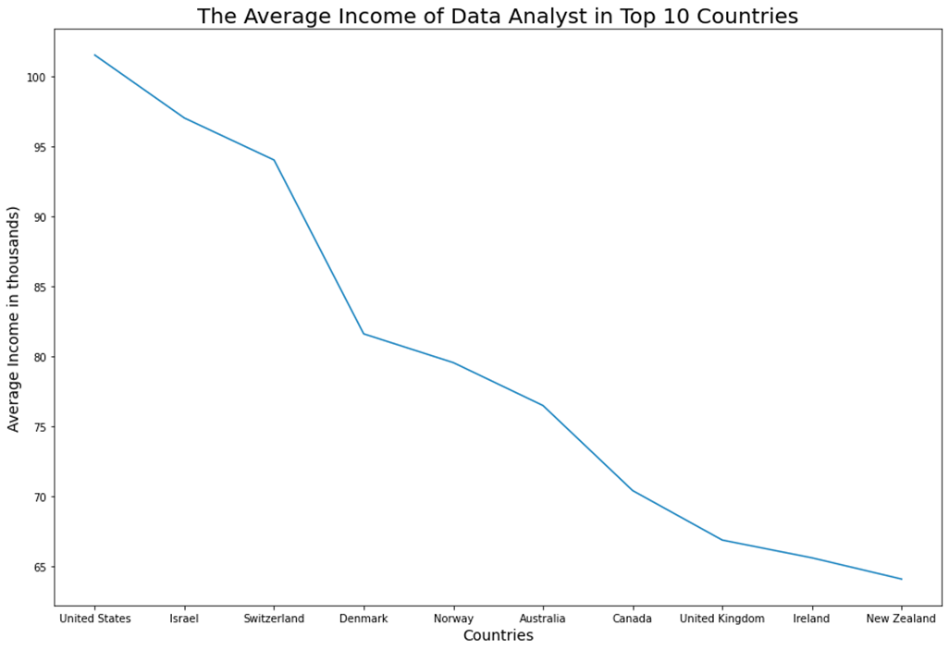

**Average:**

This line graph demonstrates critical differences in average income in the world. The data was sourced through StackOverflow, and to create the line, we used a combination of pandas and mathplotlib. The graph conveys a clear difference between income between the worlds. The US has the highest average income, with Israel just trailing behind. However, as you go through the countries, there is a significant drop in average income in other parts of the world, such as the UK, Ireland, and New Zealand. This can indicate that within the dataset, I found the US has the highest average income among the regions, and Ireland and New Zealand have the lowest average income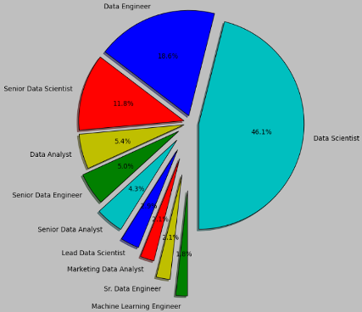

**Analysis:** The pie chart depicts a value count of Job Titles in the dataset. The most common job title is Data Scientist making up almost half of the job titles. The second common job title is Data Engineer. It was interesting to see that the Data Analyst title was ranked 4th in the data set. Unfortunately, due to GlassDoor relying on employees uploading information regarding their job titles, there is a limitation to how accurate this data set is.

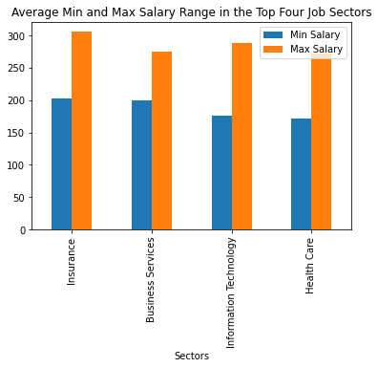

**Analysis:** The graph displays the average min and max salary range for the top four job sectors in Data Analytics. The data pool represents the standard salary range for Data Analytic jobs in the United States. Therefore, the average min and max pay ranges are similar to the four common job sectors.

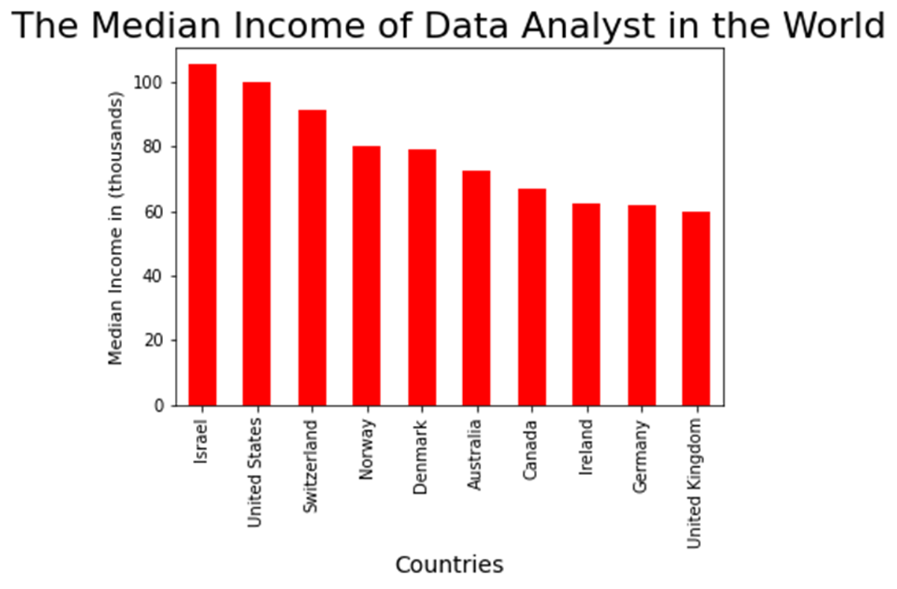

This data set which was also found on stackoverflow depicts the median range of income between several regions in the world. This bar graph was created using matplotlib and pandas using median to calculate the median income of data analyst. Identify that the income is in US currency. It goes to show that There is a wide pool over regions f

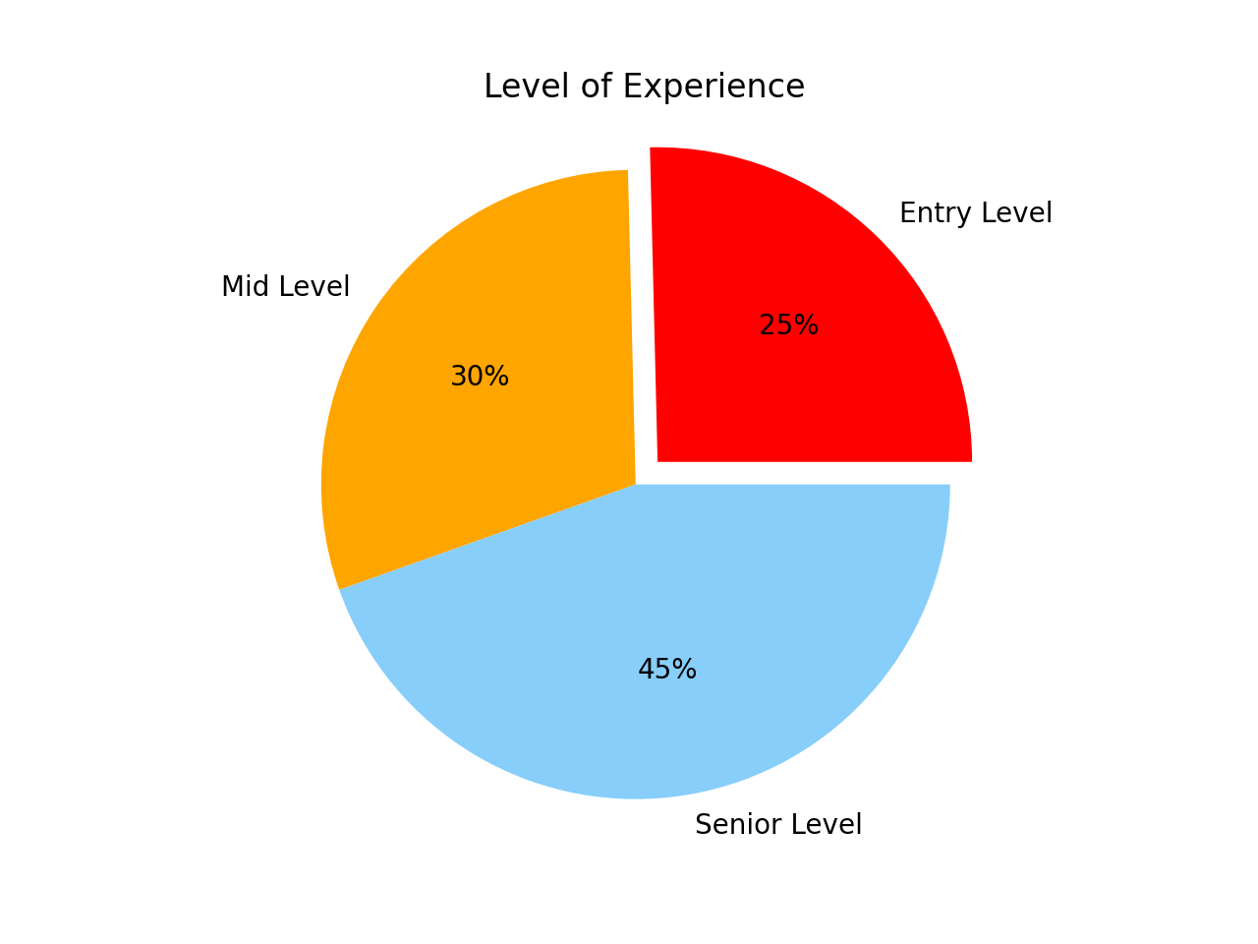

Analysis: The graph represents the levels of job experience of Data Analyst job postings that are gathered from Indeed job postings. It indicates that the senior level of Data Analyst is most needed by job postings than the mid level and entry level. This pie chart shows that the data for the level of experience is very accurate showing how much of the job postings are open for people to work in any of the related Data Analyst positions that companies are hiring based on the data.